Available online at [www.sciencedirect.com](http://www.sciencedirect.com/)



AASRI Procedia 3 (2012) 566 – 570

2012 AASRI Conference on Modeling, Identification and Control

Development of the Home Uterine Contraction Pressure Monitoring System Based on PDA

Manni Chena, Zhidong Zhaob , Changchun Shic , Honghua Yingd, Xiaoyang Feie

*aCollege of Electronics Information Hangzhou Dianzi University, Hangzhou 310018 China bCollege of Electronics Information Hangzhou Dianzi University, Hangzhou 310018 China cHangzhou Normal University, Hangzhou 310036 China*

*dJinhua People’s Hospital, Jinhua 321001 China*

*eJinhua People’s Hospital, Jinhua 321001 China*

**Abstract**

Due to be difficult for pregnant woman doing a periodic inspection at the hospital, a home uterine contraction pressure monitoring system has been developed, which consists of uterine contraction pressure signal collected unit, wireless transmission unit and PDA module. The system is built based on MCU chip-dsPIC33FJ128MC706. The uterine contraction pressure signal is acquired by load cell sensor is FSL1500N2C made by Honeywell, which can be wireless transmitted to PDA via Bluetooth. The signal can be analyzed real-time on PDA and the diagnosis can be made to prevent premature birth or occurrence of abortion effectively.

© 2012 The Authors. Published by Elsevier B.V. Open access under [CC BY-NC-ND license.](http://creativecommons.org/licenses/by-nc-nd/3.0/)

© 2012 Published by Elsevier B.V. Selection and/or peer review [under responsi](http://creativecommons.org/licenses/by-nc-nd/3.0/)bility of American Applied Science Research Institute

Selection and/or peer review under responsibility of American Applied Science Research Institute

*Keywords*: uterine contraction pressure, MCU, wireless transmission, Bluetooth, PDA;

# Introduction

Whether premature delivery or abortion, uterine contraction play a very important role. Therefore, as soon as possible to find uterine contraction caused by premature birth and threatened abortion has the extremely vital significance for early diagnosis. In recent years, due to the breakthrough of wireless transmission technology and communication technology, the medical instrument signal transmission and processing technologies rapidly develop.

Mohr Fadlee[1] builds the wireless instead of cable transmission mode of the monitor, which can make patients or doctors accept care or custody patient freely. Yuan - Haiang Lin [2] established a physiological

*Corresponding author. Tel.: +86-18767135839; E-mail address: [chen.manni2007@163.com](mailto:chen.manni2007@163.com)

2212-6716 © 2012 The Authors. Published by Elsevier B.V. Open access under [CC BY-NC-ND license.](http://creativecommons.org/licenses/by-nc-nd/3.0/) Selection and/or peer review under responsibility of American Applied Science Research Institute doi:10.1016/j.aasri.2012.11.089

signal monitoring system based on PDA, which can monitor all kinds of physiological parameters of the remote monitoring system. Sung – Nien Yu [3-4] build a set of cardiac system through the GSM wireless network transmission, the price of which was expensive and made popularization difficult.

This paper develop a portable system, which can continuous monitor uterine contraction signal and wireless transmission PDA. The signal is analyzed on PDA and the diagnosis can be made. The paper is organized as follows: section 2 introduces the hardware system design and software system is described in section 3. Experiments and results are discussed in section 4. The discussion is given in section 5.

# Hardware System Design

The schematic diagram of the system is shown in figure 1.The uterine contraction pressure acquisition terminal equipment is controlled by MCU: dsPIC33FJ128MC706, which adopts the improved Harvard architecture, optimized instruction set, 16-bit data bus and 24-bit instruction. It can address up to 4M instruction words linear program storage space and 64kb linear data storage space. The 10-bit AD converter of the MCU supports conversion rate up to 1.1Msps.

The load cell sensor is FSL1500N2C made by Honeywell in Japan, w h i c h i s u s e d t o acquire the uterine contraction pressure signal. As signal is weak, it will be amplified 100 times by the amplifier. The frequency of the signal is lower, so a 10Hz low-pass filter was designed.10-bit AD converter module of the MCU receives the analogy signal via RB15 port of the MCU, then sampled and converted by AD converter module as digital signal. Once the AD conversion is finished, the SPI module of the MCU preserve the conversion results in SD card and the conversion results can meantime be displayed on the LCD screen. RTC module obtains the current time and calendar. The I2C module of the MCU saves the calibration data in the EEPROM chip, in which data can not be easily lost when power down. The UART module of the MCU reads the conversion results. Then, the uterine contraction pressure digital signal is transmitted to PDA via HC-06 Bluetooth module.

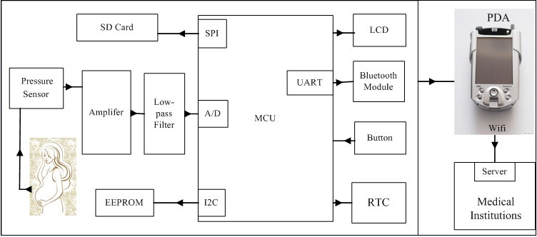

Fig. 1. System schematic diagram

# Software Design



The working flow of MCU program is shown in Figure 2. Initialize each module (UART, AD, LCD, RTC, EEPROM, SD card, etc), then wait for receiving interrupt flag to start AD conversion. When the AD conversion is finished, the conversion results can be preserved in SD card and can be displayed on the LCD screen. Menu was designed on LCD screen, which includes calibration clock, pressure value, backlight on or off for LCD screen, Bluetooth work or not, data save, etc. The MCU program will constantly scan if any button is pressed in the same interval. When pressed, the program will be interrupted and the interrupt service program will be executed. When the Bluetooth module received the instruction of start acquisition from PDA, the UART module of the PDA starts to read AD conversion results, and then, the Bluetooth transmits data to PDA. When the Bluetooth module received the instruction of stop acquisition from PDA, the UART module of the PDA stops to read AD conversion results, and the Bluetooth will stop to transmit data to PDA.



Fig. 2. Working flow chart of Software

# Experiments and Results

In order to verify the feasibility of the system, three experiments are made. The first experiment is transmission distance test. The purpose of this experiment is to test the actual wireless transmission distance of Bluetooth. Let a participants wear the instrument respectively in two different places-the seal room (indoor) and a well accept information space (outdoor), which can make a simple comparison about the daily activity space of pregnant women. The experimental results show that whether indoor or outdoor, the distance that the system can normally receiving the signal via Bluetooth are 1-7 meters. The second experiment is system calibration. The purpose of this experiment is to find out the relationship between AD values and voltages. So we establish a list to find the corresponding relationship between instrument and the pressure level. The calibration range from 0 gram to 500 gram and we use 10-bit AD converter and choose 11 pressure points for uniform calibration, as is shown in table 1.

Table 1. The relationship between AD values and pressure

Comparision object Matchup

Prssure(g) 0 50 100 150 200 250 300 350 400 450 500

AD values 8 52 99 140 182 231 279 313 363 413 443

The third experiment is the simulation wearing instrument, as the figure 3 shows. The purpose of this experiment is to analysis the feasibility of the instrument in the clinical. First of all, the pressure test on abdominal wall without uterine contraction is done. Let the participants wear the load sensor on the navel about two centimetres up, then began to calibration the system, to make the pressure value initialized. Figure 4 shows the pressure wave on PDA it shows like a horizontal line without pressure, however, a wave appears after a deep breathing. In future, the clinical trials will be done at hospital.

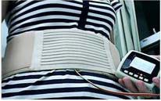

Fig. 3. Wearing instrument simulation

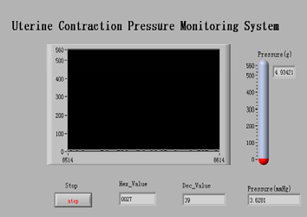 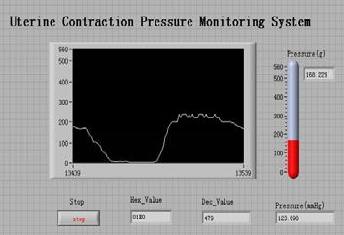

Fig. 4. Pressure wave on PDA

# Conclusion

In this paper, we designed a uterine contractions pressure monitoring system based on PDA. It shows that the operation of the system is stable and reliable, easy to carry, simple to operate and low cost, which is suitable for ordinary household of pregnant woman. In future, a large number of clinical tests on pregnant women in different situations will be done…

# Acknowledgements

This work was supported in part by the Science project of Science Technology Department of Zhejiang Province Grant No.2012C21005  and the Science project of Science Technology Bureau of Jinhua(Grant No.2011-3-012).

# References

1. R. M. F.A., “Bluetooth telemedicine Processor for multichannel biomedical signal transmission via mobile cellular networks”, IEEE Transactions on Information Technology in Biomedicine, Volume 9, Issue l, March 2005.
2. S. P. Nelwan, T.B. van Dam, P. Klootwijk, and S. H. Meij, “Ubiquitous mobile access to real-time patient monitoring data” Compute. Cardiology, bol. 29, pp. 557-560, Sept. 2002.
3. J. R. Chang Chien and Cheng-Chi Tai, “The Study of a Wireless, Portable, and Real-Time Physiological Signal Monitoring System by Combining Bluetooth Technique and PDA Hand Computer”, National Cheng Kung University M. A. thesis, 2004.
4. M Brusco and H Nazeran, Development of an intelligent PDA-based wearable digital phonocardiograph. Proceedings of the IEEE Engineering in Medicine and Biology 27th Annual Conference, 2005, pp.3506-3509.

# Contact of Corresponding Author:

Name: Manni CHEN Email: [chen.manni2007@163.com](mailto:chen.manni2007@163.com) Tel: +86-18767135839